Contents

Founder 2

Introduction of Jeff Bezos 2

2. Introduction 3

3. why it is called Amazon.? 4

4. What was the first product.? 5

5. how to sell on amazon. 6

6. danger to selling on amazon. 7

7. Amazon’s biggest failure. 8

8. growth of Amazon through launching new product 8

9. From bookstore to super store. 10

10. conclusion 11

Figure 1: jeff Bezos 2

Figure 2: Amazon logo 3

Figure 3:Amazon old logo 4

Figure 4: Amazon book 6

Figure 5:Amazon danger 8

Figure 6: Amazon project 9



**Student Research Report on Amazon**

1. **Title of innovation**

Amazon (shopping app)

# Founder

Founder Name with picture

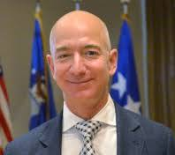

Figure 1: jeff Bezos

Jeff Bezos

## Introduction of Jeff Bezos

***Who doesn’t love a startup story and what better than knowing about the men in the world?***

***A person who was born on January 12, 1964, in New Mexico. His first love is computer and studied computer science and electrical engineering at Princeton University. After graduation he worked on Wall Street.***

***In 1990, He became the youngest senior vice president at the investment firm D.E. Shaw. After four years, He quit his job to open amazon.com. This person is none other than JEFFERY P. BEZOS.***

***Bezos started his first business at school. It was called the dream institute and it was an educational summer camp for fourth, fifth, sixth standard students. There were some books that Bezos required his participants to read.***

# 2. Introduction

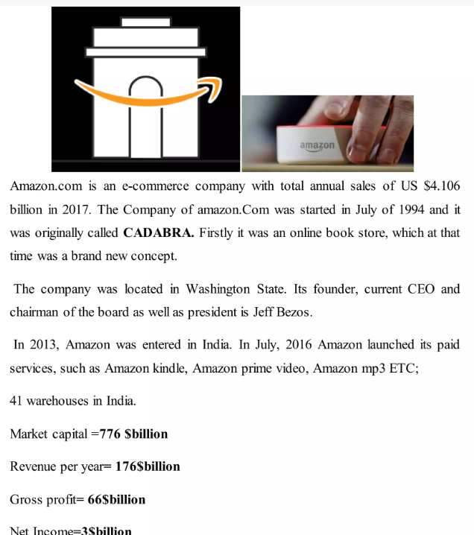

Figure 2: Amazon logo

*Amazon.com is an e-commerce company with total annual sales of US $4.106 billion in 2017. The company of Amazon.com was started in July of 1994 and it was originally called CADABRA. Firstly, it was an online book store, which at that time was a brand-new concept.*

*The company was located in Washington State. Its founder, current CEO and chairman of the board as well as president is Jeff Bezos.*

*In 2013, Amazon was entered in India. In July 2016, Amazon launched its paid services, such as Amazon Kindle, Amazon Prime Video, Amazon MP3, etc.*

*41 warehouses in India.*

*Market capital = 776 $billion  
Revenue per year = 176 $billion  
Gross profit = 66 $billion  
Net Income = 3 $billion*

# 3. why it is called Amazon.?

*Amazon was originally called* ***“Cadabra”****, as in* ***“abracadabra”****. According to Brad Stone’s book* ***“The Everything Store”****, Bezos’s lawyer told him the reference to magic was too unclear.*

*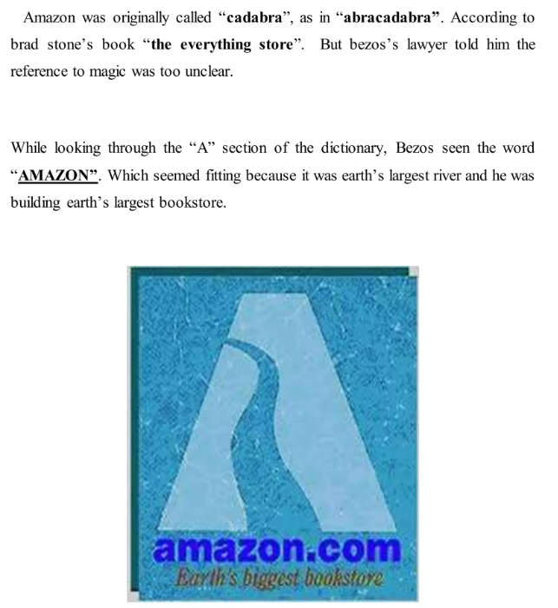While looking through the “A” section of the dictionary, Bezos saw the word* ***“AMAZON”****. Which seemed fitting because it was Earth’s largest river and he was building Earth’s largest bookstore.*

Figure 3:Amazon old logo

# 4. What was the first product.?

*The first product was a book on Amazon. The name of the book was “Fluid Concepts and Creative Analogies”: Computer Models of the Fundamental Mechanism of Thought in the year 1995. An exclusive bookstore that became one of the internet’s biggest success stories.*

*Amazon began its success selling books online, across America and* ***45*** *other countries within* ***30*** *days. In two months, sales reached* ***$20,000 a week****, growing faster than Bezos could have imagined.*

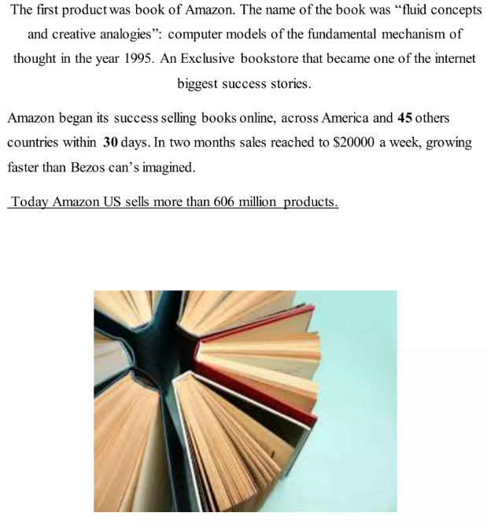**Today Amazon US sells more than 606 million products.**

Figure 4: Amazon book

# 5. how to sell on amazon.

**1*. Register a new Amazon sellers account,***

* *If you want to sell anything on the site, the first thing you will need is an Amazon seller account. For that, you have to create a username and password.*

***2. Enter your complete accurate details,***

* *Add seller information detailing your desired display name, appropriate address, and other applicable information necessary for a valid transaction.*

***3. Select your sustainable plan,*** *Then decide whether you want to be a professional or individual seller:*

* *The individual plan is the best for those who only want to sell a few items (this plan is entirely free).*
* *The professional plan is for those who want to sell in bulk (this plan runs a monthly subscription fee of $40).*

***4. Verify with your phone number,***

* *Verify said information first. You have to enter your name and phone number and click the yellow “Call Me Now” button. You will receive a call from Amazon and, when prompted, enter the PIN number appearing on your screen on your phone prior to hanging up. You will see a verification message indicating that you are ready to begin selling on Amazon.*

# 6. danger to selling on amazon.

1. # Evil strategy  
Never ever depend on Amazon marketplace as a primary stream of revenue because your business can literally disappear overnight or sometimes the company closes the seller account for any reason, not only limited to any kind of complaint, policy violation. They don’t have any valid reason, still they eliminate sellers from the platform.

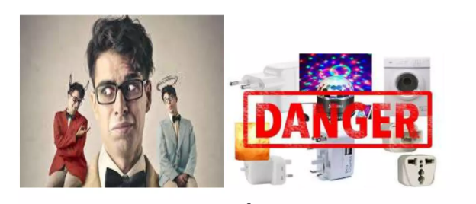2. # Evil strategy  
If you are an Amazon seller and you have not registered your brand, you need to be very careful about the other sellers; because competitors can change the photo of your listing without any notification. So, whenever a customer buys from you and notices the product doesn’t match the photo, they could complain and ding your account.

Figure 5:Amazon danger

# 7. Amazon’s biggest failure.

* **Fire phone**
* **Destinations**
* **Music importer**
* **Test drive**
* **Amazon web pay**
* **Arkville**

**The typical response from Amazon after shutting down this failed project is “we have learned a great deal and will look for ways to apply this lesson in the future as we continue to innovate on behalf of our customer.”**

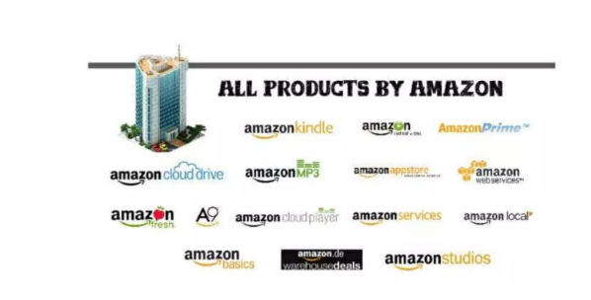8. growth of Amazon through launching new product**.**

Figure 6: Amazon project



A kindle is a small electronic device for regarding **books** which has been developed by Amazon. People can easily download and read books, magazines, newspapers and other digital media via wireless technology on to a kindle.

**2. Amazon cloud drive**  
Amazon cloud drive is a **storage application management** by Amazon. It gives secure cloud storage free for your unlimited photos, videos and other files with access from your mobile and laptops etc.

**3. Amazon cloud player**  
Amazon recently introduce cloud player an internet-based service that allows you to store up to **5GB** of **music** and access that music from web browser. Amazon mp3, click launch player and there are your uploaded tracks. One good way to organize your music is to create playlists.

**4. Amazon local**  
According to its website, Amazon will all that shut down its **“daily deals”** sites. Amazon local on December 18, 2018. Any voucher you have already purchased won’t be affected by the change and you will easily purchase deals as you normally would until the shutdown date. Here, is the notice posted on Amazon site.



Amazon basic is, I would like to mention here about this is a written by Hectors Quintanilla.

* Amazon will copy your product.
* Add their private label “Amazon basic” to it.
* Sell it at an unbeatable price.
* Attach free Amazon Prime shipping too.

# 9. From bookstore to super store.

1. **Set a long-term goal instead of speedy payout,**
   * The long-term goal setting is the key to mastering achievement while many new online entrepreneurs were setting their market for speedy growth.
2. **Excellent customer service,**
   * Customer service at Amazon is not design to field complains and queries but it’s an opportunity to improve the company’s relationship to its customer.
3. **Global resources available,**

Amazon has global resources that span around the world. Which means they are already supplied to handle large volume from a wide diversity of resources including having access to 80 enormous warehouses and fulfillment center.

1. **. Efficient tracking system,**  
   -One of the essential keys of Amazon success is handling large volumes in an efficient and expeditious manner. Each facility has access to barcode technology so that the packages shipped can be tracked in virtually any place.
2. **Customer review,**  
   -Sometimes customer cannot make a decision whether to buy it from online or not because online shopping is a different experience. In this case customer can view what other customer are saying about the product (positive or negative). It helps to take a decision.
3. **. Customer enjoys a personalized shopping experience,**  
   -Online shopping can be challenging and time consuming. so, Amazon has already seen the future of shopping and has a respond according to customer needs. That’s why it will be save the customer time as well as money.

# 10. conclusion

“Google is a vast ocean of knowledge,  
Face book is a vast ocean of relation,  
AMAZON is a vast ocean of getting things by touch point.”

Sometime something sound to be true  
than there will be always unseen disadvantage.

***1.******What real world problem did they solve?***

* 1. Convenient and Fast Shopping
* Supply Chain and Fulfillment Efficiency
* Cloud Infrastructure Access (AWS)
* Voice-Activated Technology
* Access to Books and Publishing

***2. What was the founder’s thought process?***

* Spotting a Growth Opportunity
* Choosing the Right Product to Sell
* Customer Obsession
* Long-Term Thinking
* Relentless Innovation and Risk-Taking